Project Design Phase-II
Technology Stack (Architecture & Stack) — Blog Nest
Project Name: Blog Nest
Document Purpose: Technical architecture and technology-stack documentation based on the supplied Technology Stack template.
Maximum Marks: 4 Marks

Technical Architecture
Blog Nest is designed as a three-tier web application. The presentation layer provides the reader, author and administrator interfaces; the application layer handles authentication, blog management, comments and APIs; and the data layer stores users, posts and comments. Media files such as blog images are kept in dedicated file/object storage.
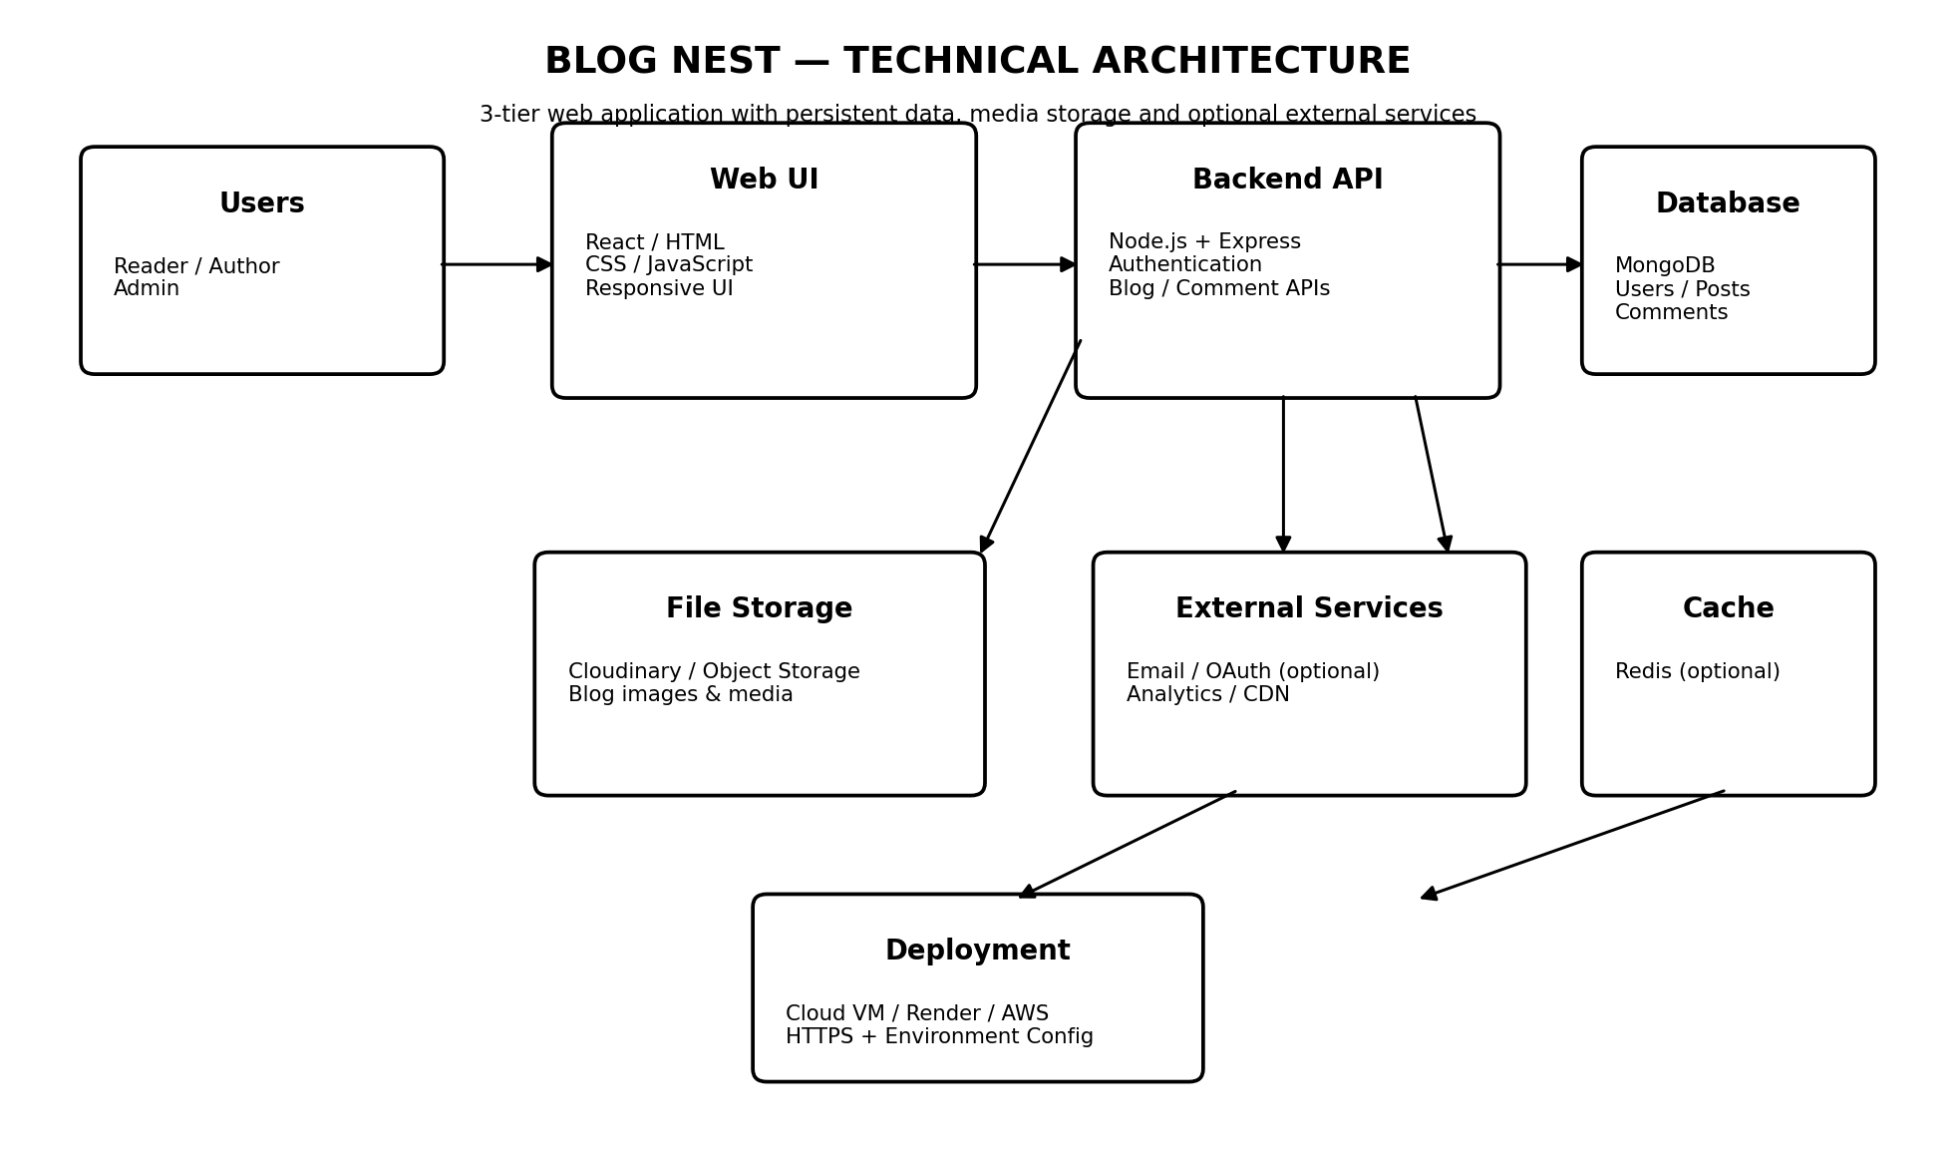

Architecture Guidelines
- Include all major application processes as application-logic / technology blocks.
- Separate local development infrastructure from cloud deployment infrastructure.
- Identify external interfaces such as optional email, OAuth, analytics or CDN services.
- Identify persistent data-storage components and media/file-storage services.
- Machine-learning integration is not required for the core Blog Nest architecture; it can be added later as an optional recommendation or content service.

Table-1: Components & Technologies
S.No | Component | Description | Technology
1 | User Interface | Web interface for readers, authors and administrators. | React.js / HTML / CSS / JavaScript
2 | Application Logic-1 | Authentication, authorization and user management. | Node.js + Express.js
3 | Application Logic-2 | Create, read, update and delete blog posts. | Node.js + Express.js REST API
4 | Application Logic-3 | Comments, categories/tags and moderation workflows. | Node.js + Express.js
5 | Database | Stores users, posts, comments, categories and metadata. | MongoDB
6 | Cloud Database | Managed database option for production deployment. | MongoDB Atlas
7 | File Storage | Stores blog cover images and uploaded media. | Cloudinary / Object Storage
8 | External API-1 | Optional email notifications, password reset or transactional email. | Email API / SMTP service
9 | External API-2 | Optional third-party login and identity provider. | Google OAuth / OAuth 2.0
10 | Machine Learning Model | Optional future feature for recommendations, tagging or moderation. | Not required for core Blog Nest; can be integrated through a REST/AI API
11 | Infrastructure (Server / Cloud) | Hosts the frontend, backend and managed services. | Local development; production on Render / AWS / similar cloud platform

Infrastructure Configuration
Local Server Configuration:
Developer machine running React frontend, Node.js/Express backend and MongoDB locally or through a local/remote development database.
Cloud Server Configuration:
Cloud-hosted frontend and backend, managed MongoDB database, object/media storage, HTTPS, environment variables and optional CDN/cache.

Table-2: Application Characteristics
S.No | Characteristics | Description | Technology
1 | Open-Source Frameworks | Frameworks and libraries used to build the application. | React.js, Node.js, Express.js
2 | Security | Authentication, role-based access, password hashing, HTTPS, input validation and secure environment configuration. | JWT/session authentication, bcrypt/Argon2, HTTPS, OWASP practices
3 | Scalable Architecture | Three-tier separation allows the UI, API and database services to scale independently. | React + Express REST API + MongoDB; optional Redis/CDN
4 | Availability | Cloud deployment, managed database and independent services reduce single points of failure. | Cloud hosting, MongoDB Atlas, health checks; optional load balancer
5 | Performance | API pagination, database indexing, compressed media, browser caching and optional CDN/cache improve response time. | MongoDB indexes, Redis optional, CDN, optimized images

References
- Supplied Technology Stack (Architecture & Stack) template — used as the structure and terminology for this document.
- C4 Model — https://c4model.com/
- AWS Architecture — https://aws.amazon.com/architecture/
- IBM Cloud Architecture — https://www.ibm.com/cloud/architecture

